Active Directory Basics – TryHackMe Lab Documentation
Author: Kay
Role: IAM & Cybersecurity Professional
Lab: TryHackMe – Active Directory Basics
Date: 3/12/26

1. Overview
This document summarizes my hands-on work in the TryHackMe Active Directory Basics lab. The environment simulated a Windows domain with a domain controller, servers, and domain-joined endpoints. The goal was to understand how Active Directory manages identities, authentication, and access across an enterprise network.

2. Domain Architecture
The lab environment included the following components:
- Domain Controller – central identity store and authentication authority
- File Server – shared resource management
- Database Server – backend system relying on domain authentication
- Workstation – domain-joined endpoint for user login testing
- Desktop – additional endpoint for observing policy and access behavior
Screenshot: 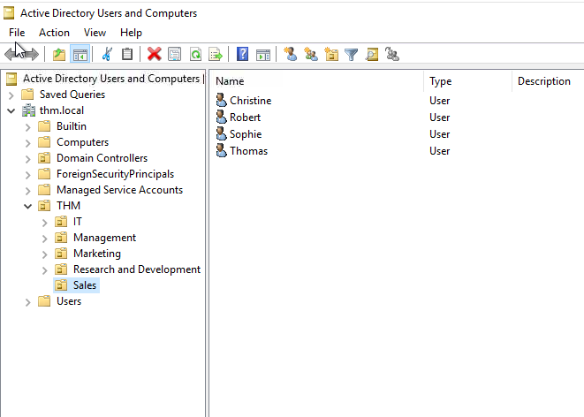

3. Active Directory Exploration
Tasks completed:
- Navigated Active Directory Users and Computers (ADUC)
- Reviewed domain structure, OUs, users, and groups
- Observed how identity objects are organized
- Examined group membership and privilege levels

4. User & Group Administration
Key administrative actions performed:
- Reset a domain user’s password
- Forced password change at next logon
- Validated authentication using domain format (THM\username)
- Logged into the user’s workstation to confirm changes

PowerShell Action:
Code
Set-ADUser -ChangePasswordAtLogon $true -Identity sophie -Verbose
Screenshot: 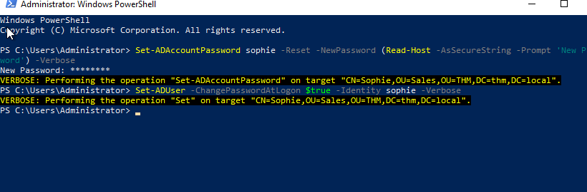

5. Authentication & Access Validation
After updating the user account, I logged into the workstation using:
- Username: THM\sophie
- Password: new password set earlier
Once logged in, I accessed the user’s desktop to retrieve the assigned flag file, confirming:
- Successful domain authentication
- Proper profile creation
- Correct application of user permissions
Screenshot: 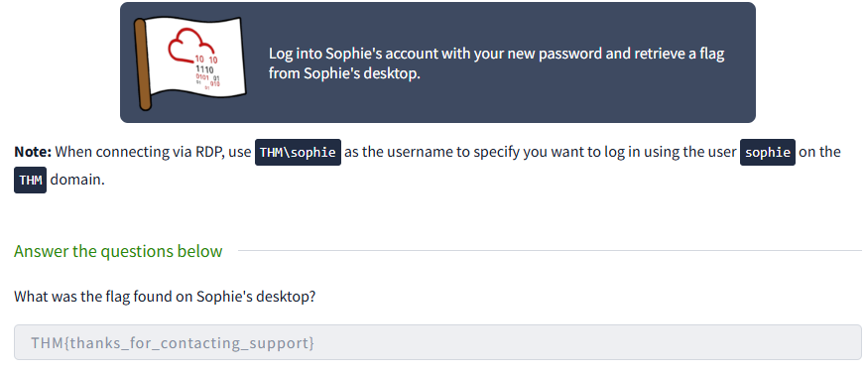

6. Group Policy Configuration: Restricting Control Panel Access
After validating Sophie’s login and retrieving the flag, I moved on to configuring Group Policy to enforce workstation restrictions across multiple departments.

6.1 Created a New GPO
I created a new Group Policy Object designed to restrict access to the Windows Control Panel for standard users. This policy included:
- Disabling Control Panel access
- Preventing changes to system settings
- Enforcing consistent workstation configuration across departments

6.2 Linked the GPO to Target Organizational Units
To ensure only the appropriate users were restricted, I linked the new GPO to the following OUs:
- Management
- Marketing
- Sales
These OUs represent departments where users should not have administrative control over their PCs.

6.3 Verified Policy Application
I confirmed that:
- The GPO appeared under each linked OU
- The inheritance order was correct
- No conflicting policies were overriding the restriction
Screenshot:
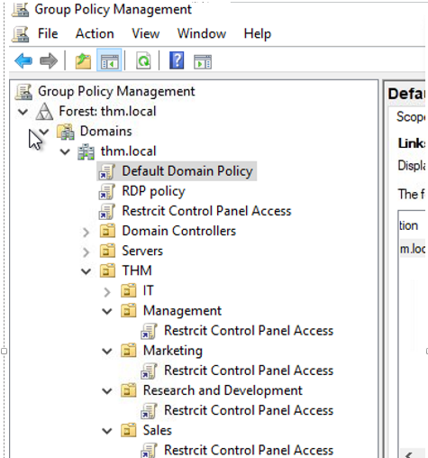

7. Key Concepts Reinforced
This lab strengthened my understanding of:
- Kerberos vs NTLM authentication
- Group Policy Objects (GPOs)
- Identity lifecycle management
- Least privilege access
- Domain resource access control
- How AD underpins enterprise IAM

8. Professional Takeaways
This lab directly supports my IAM and cybersecurity career path by reinforcing:
- Identity administration fundamentals
- Windows domain security concepts
- Real-world user and group management
- Authentication troubleshooting
- Enterprise identity governance principles

9. Conclusion
The TryHackMe Active Directory Basics lab provided practical experience with domain administration and identity management. These skills are foundational for roles in IAM, SOC operations, cloud security, and enterprise cybersecurity.

